



<https://www.google.com/maps/place/2795+San+Leandro+Blvd,+San+Leandro,+CA+94578/@37.714679,-122.1467378,17z/data=!3m1!4b1!4m5!3m4!1s0x808f8fc4f3b67773:0x1f7eee700062030f!8m2!3d37.7146748!4d-122.1445438>

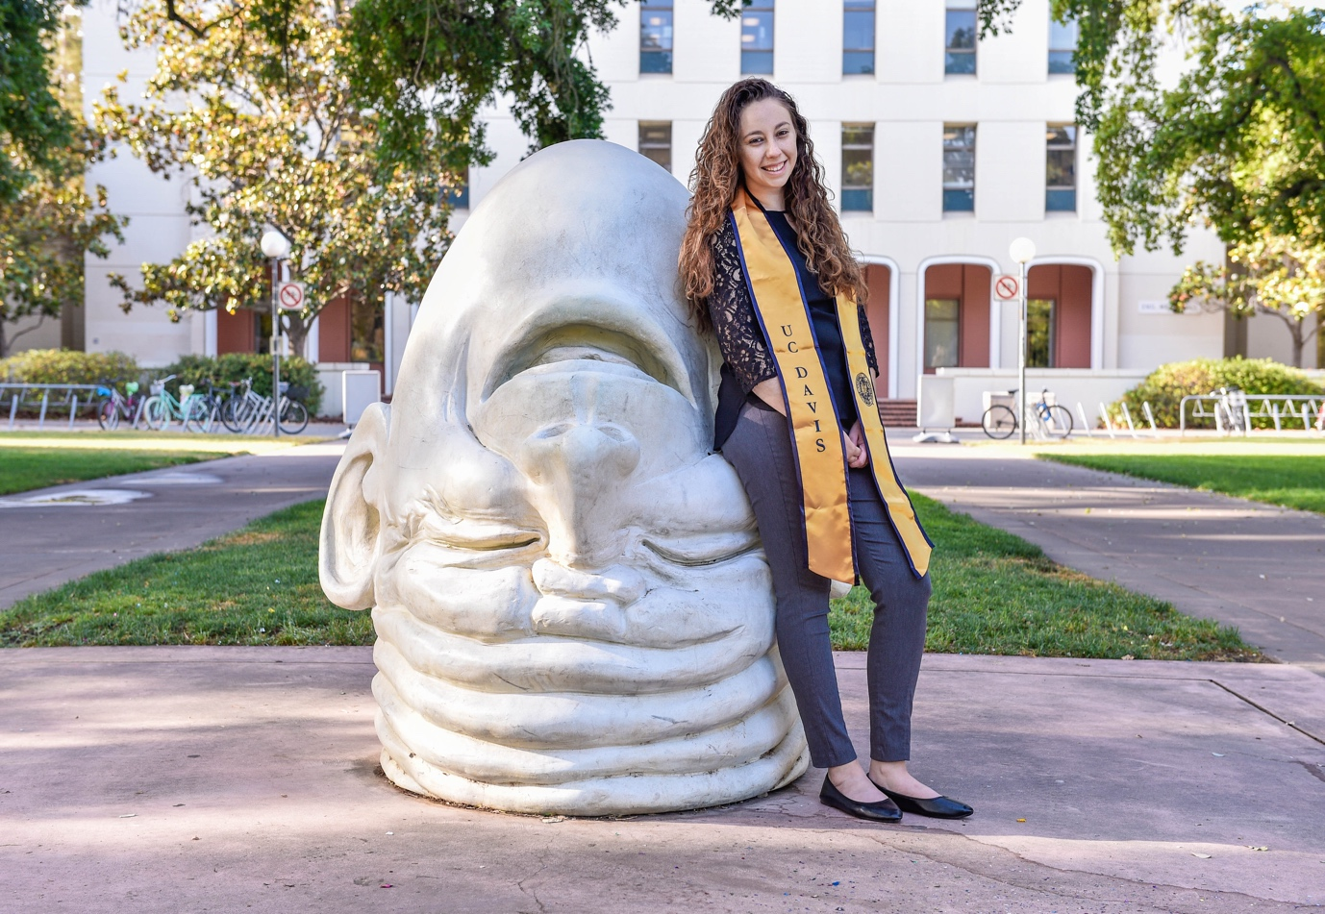







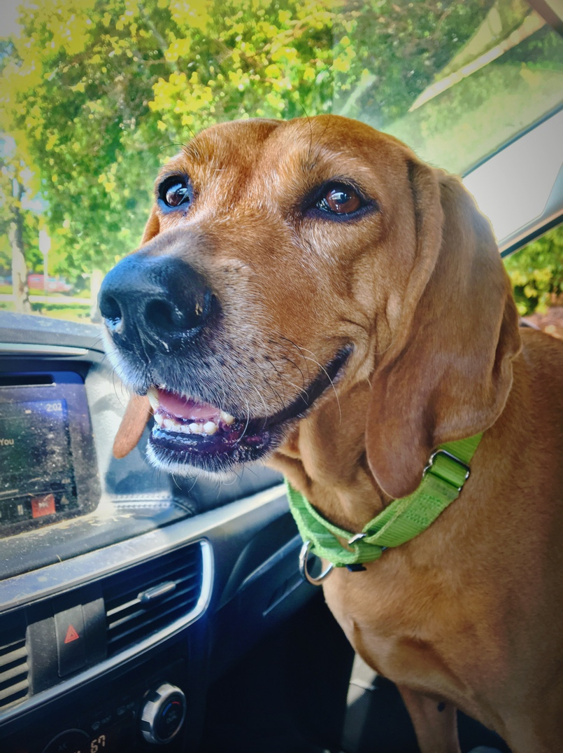

#62b7a4